OPM - Data Migration - Processor Module Assembly
Deployment Guide

Revision History
Author | Revision Number | Date
sparemax | 1 | 01/08/2014

Deployment Instructions 3
1. Organization of Submission 3
2. Application Setup 3
3. Ant .Properties File (Only jboss.home and db.* properties are required for this assembly) 4
4. Build Scripts Setup 4
5. Database Setup 5
5.1 PostgreSQL 5
5.2 SQL Server 6
6. Deployment Instructions (No need for this assembly) 6
7. Starting (No need for this assembly) 7
8. Verification 7
8.1 JUnit Tests 7
8.2 Command Line Tests 7
9. Resource Contact List 8

Deployment Instructions

Organization of Submission

Folder | Description
conf | Contains application configuration files
lib | Contains dependencies
testlib | Contains test dependencies
src | Contains all source files
docs | Contains documentation (this file)
test_files | Contains the test files
log | Contains the test log files
conf/jpa | Contains the JPA mapping and persistence configuration
conf/ejb | Contains the EJB configuration
conf/rules | Contains the business rule definitions
conf/web | Contains the web application configuration files (including spring MVC bean definitions)
conf/ear | Contains application wide configuration (including the datasource definition)
conf/jboss | Contains application changes to the JBoss configuration
conf/migration | Contains data migration configuration
src/web | Contains the web application sources
src/java/core | Contains java sources shared across modules
src/java/ejb | Contains java sources for the EJB module
src/java/web | Contains java sources for the front end web application
src/java/tests | Contains java test sources
build-dependencies.xml | Declaration of build dependencies
build.properties | Externalized build configuration
build.xml | Ant build script

Application Setup

The application is tested with the following stack

- Java 6 (http://www.oracle.com/technetwork/java/javase/downloads/index.html)
- JBoss EAP 6.1 (http://www.jboss.org/jbossas/downloads/)
- Ant 1.8.1 (http://ant.apache.org/)
- PostgreSQL 9.2.4 (http://www.postgresql.org/)
- SQL Server 2008 R2 (http://www.microsoft.com)

The following 3rd party libraries are packaged with the submission
- Drools 5.5
- Spring MVC 3.2.3
- Hibernate 4.2.3
- Jackson 2.2.3
- Joda-Time 2.3
- JUnit 4.10
- PostgreSQL JDBC Driver
- SQL Server JDBC Driver

Ant .Properties File (Only jboss.home and db.* properties are required for this assembly)

Property Name | File property is stored | Example Setting
jboss.home | build.properties | D:/Servers/jboss-eap-6.1
loggerName | build.properties | gov.opm.scrd
log_dir | build.properties | D:/opm_log
postedPendingApprovalStatus.id | build.properties | 1
postedPendingApprovalStatus. name | build.properties | Payment Status 1
redepositPeriodType.id | build.properties | 1
redepositPeriodType. name | build.properties | DEPOSIT
dedepositPeriodType.id | build.properties | 2
dedepositPeriodType. name | build.properties | DEDEPOSIT
csrsRetirementType.id | build.properties | 1
csrsRetirementType. name | build.properties | Retirement Type 1
successCalculationStatus.id | build.properties | 1
successCalculationStatus. name | build.properties | Calculation Status 1
db.driver | build.properties | org.postgresql.Driver
db.url | build.properties | jdbc:postgresql://localhost:5432/scrd
db.user | build.properties | postgres
db.pass | build.properties | 123456
db.sourceDatabaseDriverName | build.properties | com.microsoft.sqlserver.jdbc.SQLServerDriver
db.sourceDatabaseUrl | build.properties | jdbc:sqlserver://localhost:1433;databaseName=ServiceCredit;
db.sourceDatabaseUsername | build.properties | sa
db.sourceDatabasePassword | build.properties | 123456

Build Scripts Setup

build.xml – compiles, packages and deploys the application
Main targets:

clean removes all generated files
compile-core compiles shared java sources
compile_tests compiles java test sources
test run the test cases
compile-ejb compiles EJB java sources
compile-war compiles web application java sources
configure-ear performs replacement of values for EAR configuration files
configure-ejb performs replacement of values for EJB configuration files
configure-war performs replacement of values for web app configuration files
db-clear clears the contents of the tables
db-create creates the tables and sequences
db-drop drops the tables and sequences
db-test-data recreates the test data
source-clear clears the contents of the tables in source database
source-create creates the tables and sequences in source database
source-drop drops the tables and sequences in source database
source-test-data recreates the test data in source database
deploy deploys the EAR artifact
deploy-jdbc-driver copies the jdbc driver module into jboss
dist-core creates the core distribution
dist-ear creates the EAR artifact
dist-ejb creates the EJB distribution
dist-war builds the war file
dist-migration builds the jar file
exec-migration performs the data migration

Default target: test

Database Setup

Note: for some steps, you can use the ant script to execute them, but make sure you configure the build.properties first.

5.1 PostgreSQL
- Setup PostgreSQL 9.2.4
- Create the database “scrd” using your client. (you may change the DB name, but update your JDBC URL accordingly)

- Execute script src/sql/create-schema.sql and src/sql/triggers.sql to create the required objects (“ant db-create” will perform the same step)
- Execute script src/sql/initial-data.sql to insert test data (“ant db-test-data” will perform the same step)

Setup Database Driver module on JBoss

- Copy conf/jboss/modules into the modules folder of your EAP installation -${jboss.home}/modules/system/layers/base (“ant deploy-jdbc-driver” will perform the same step)
- Add the following entry to ${jboss.home}/standalone/configuration/standalone.xml just after the h2 driver declaration on the datasources/drivers subsystem

<driver name="postgresql-jdbc4" module="org.postgresql">
<driver-class>org.postgresql.Driver</driver-class>
</driver>

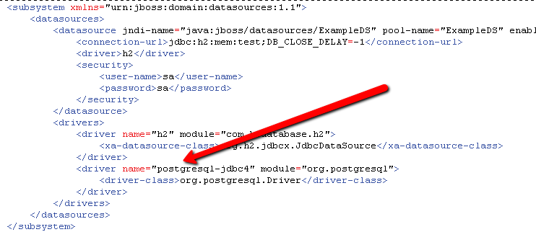

Note: This step can also be done via the jboss command line interface with the following command:

/subsystem=datasources/jdbc-driver=postgresql-jdbc4:add(driver-name=postgresql-jdbc4, driver-class-name=org.postgresql.Driver, driver-module-name=org.postgresql)

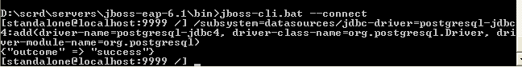

Cleanup scripts: (execute only when done with testing)
• When needed, execute src/sql/clear-data.sql to clear the database tables(“ant db-clear” will perform the same step)
• When needed, execute script src/sql/drop-schema.sql to delete all application objects (“ant db-drop” will perform the same step)

5.2 SQL Server
- Setup SQL Server 2008 R2
- Create the database “ServiceCredit”
- Execute script src/sql/create-ServiceCredit.sql to create the required objects (“ant source-create” will perform the same step)
- Execute script src/sql/source-data.sql to insert test data (“ant source-test-data” will perform the same step)

Cleanup scripts: (execute only when done with testing)
• When needed, execute src/sql/clear-source.sql to clear the database tables(“ant source-clear” will perform the same step)
• When needed, execute script src/sql/drop-ServiceCredit.sql to delete all application objects (“ant source-drop” will perform the same step)

Deployment Instructions (No need for this assembly)

- Modify build.properties to reflect the deployment environment settings. (log_dir must be an existing directory)
- Setup the database as described in the previous section
- Execute “ant deploy”

Starting (No need for this assembly)

Start JBoss. The application is automatically started when the JBoss server is started.

Please note that you may receive a warning (JBAS011054) regarding EAP 6.1 and Spring 3.2.3, you may safely ignore this warning per

https://community.jboss.org/thread/231638?start=0&tstart=0

Verification

8.1 JUnit Tests
To run the tests: execute ‘ant test’

The log files are under /log directory.

8.2 Command Line Tests
To perform the data migration: execute ‘ant exec-migration’

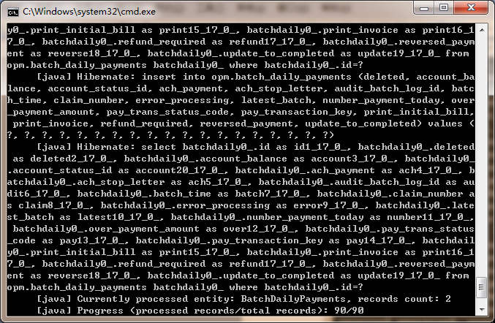

Resource Contact List

Name | Resource Email
TCSASSEMBLER

